https://www.youtube.com/watch?v=FAJHD-uKPJI&list=PLi5spBcf0UMXj6bD3S05yixR-2N_UH3_X Power BI and Python Machine Learning A to Z Part 1: Installing Python sigue part2 a part7

https://www.youtube.com/watch?v=l-83AtuHqM0&list=PLi5spBcf0UMVz2SwJ_Us5PyVTCvwEXWgo Machine Learning in Power BI Absent Data
https://www.youtube.com/watch?v=mhe9Vs3jQes&list=PLi5spBcf0UMVz2SwJ_Us5PyVTCvwEXWgo&index=2 Sentiment Analysis in Power BI Absent Data
https://www.youtube.com/watch?v=0zveIwThlfE&list=PLi5spBcf0UMVz2SwJ_Us5PyVTCvwEXWgo&index=3 Sales Prediction Model with Python and Power BI Absent Data ml35abc
Using Power BI Field Parameters to add Measure Slicers to a Report
https://www.youtube.com/watch?v=ShvY09LfHBE
Two Ways to Create Single Value Input Slicers in Power BI!
https://www.youtube.com/watch?v=2CFIm8dtcik
https://www.sqlbi.com/articles/how-to-enable-the-single-value-option-in-a-power-bi-slicer/

https://www.youtube.com/watch?v=obSQuZe87Ac&list=PLi5spBcf0UMVz2SwJ_Us5PyVTCvwEXWgo&index=4 Machine Learning Anomaly Detection with Python and Power BI AbsntData

https://www.youtube.com/watch?v=lomJnbN5Wnk&list=PLat2DtY8K7YWG4QxUruT1IB_sHumOr1Si
Curso de Inteligencia Artificial (IA) y Machine Learning con Python
https://www.youtube.com/watch?v=lomJnbN5Wnk&t=0s

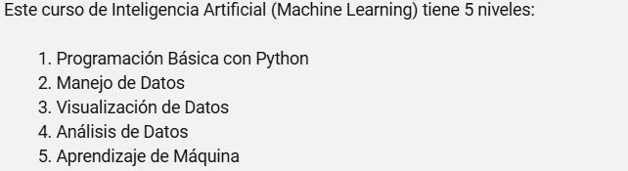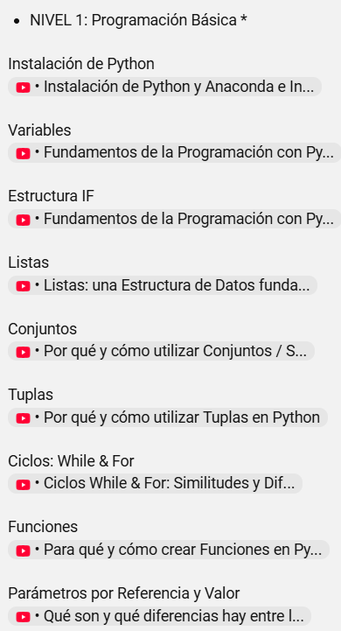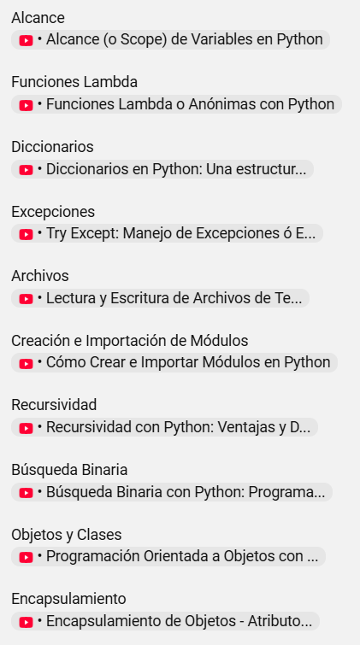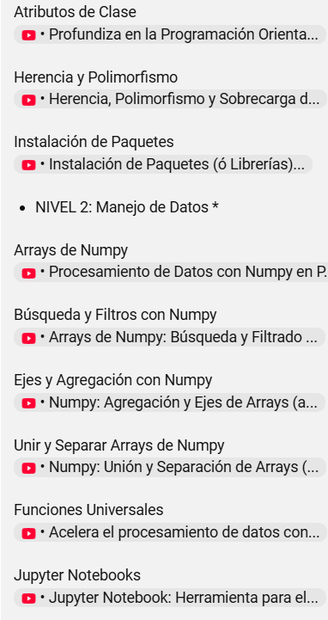
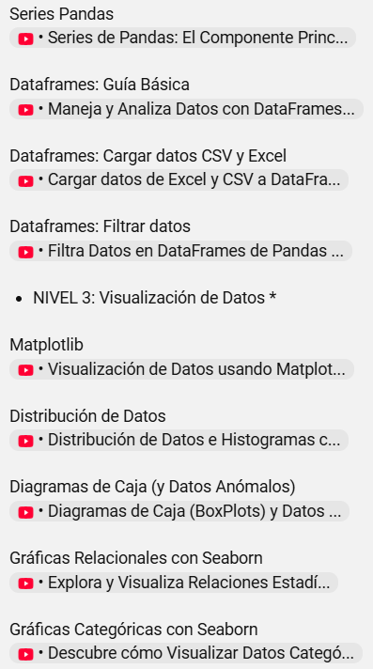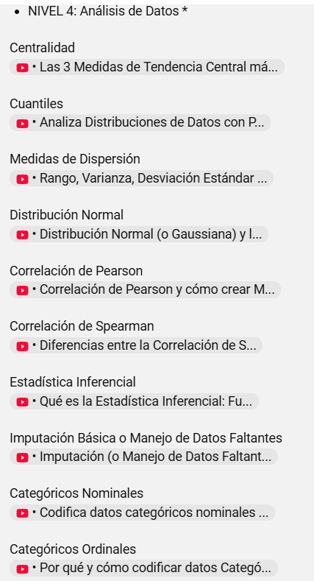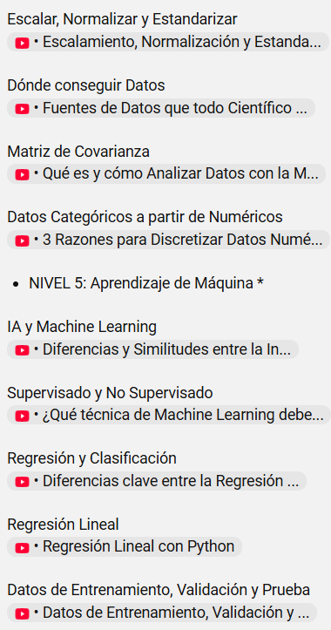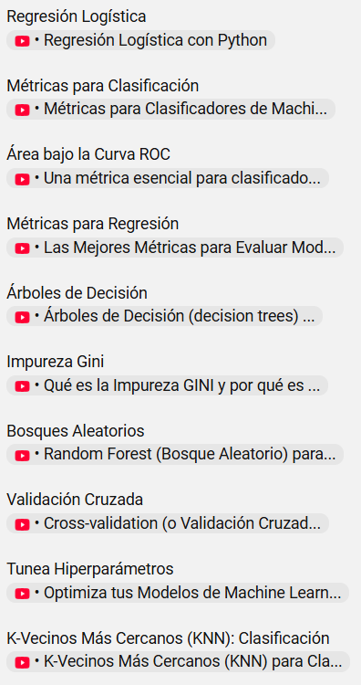

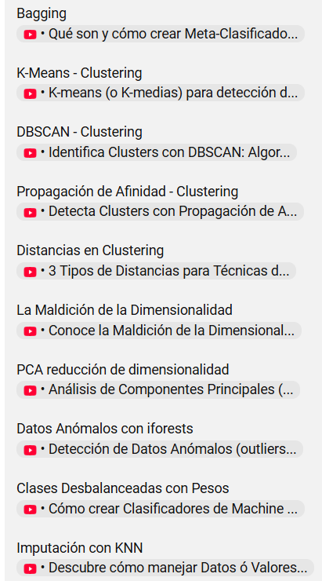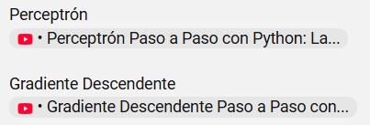
https://github.com/mwaskom/seaborn-data/blob/master/penguins.csv

